Git ststus

Git add .

Now check vo add hua ki nhi by use git status

Dhek green hoi ki koni

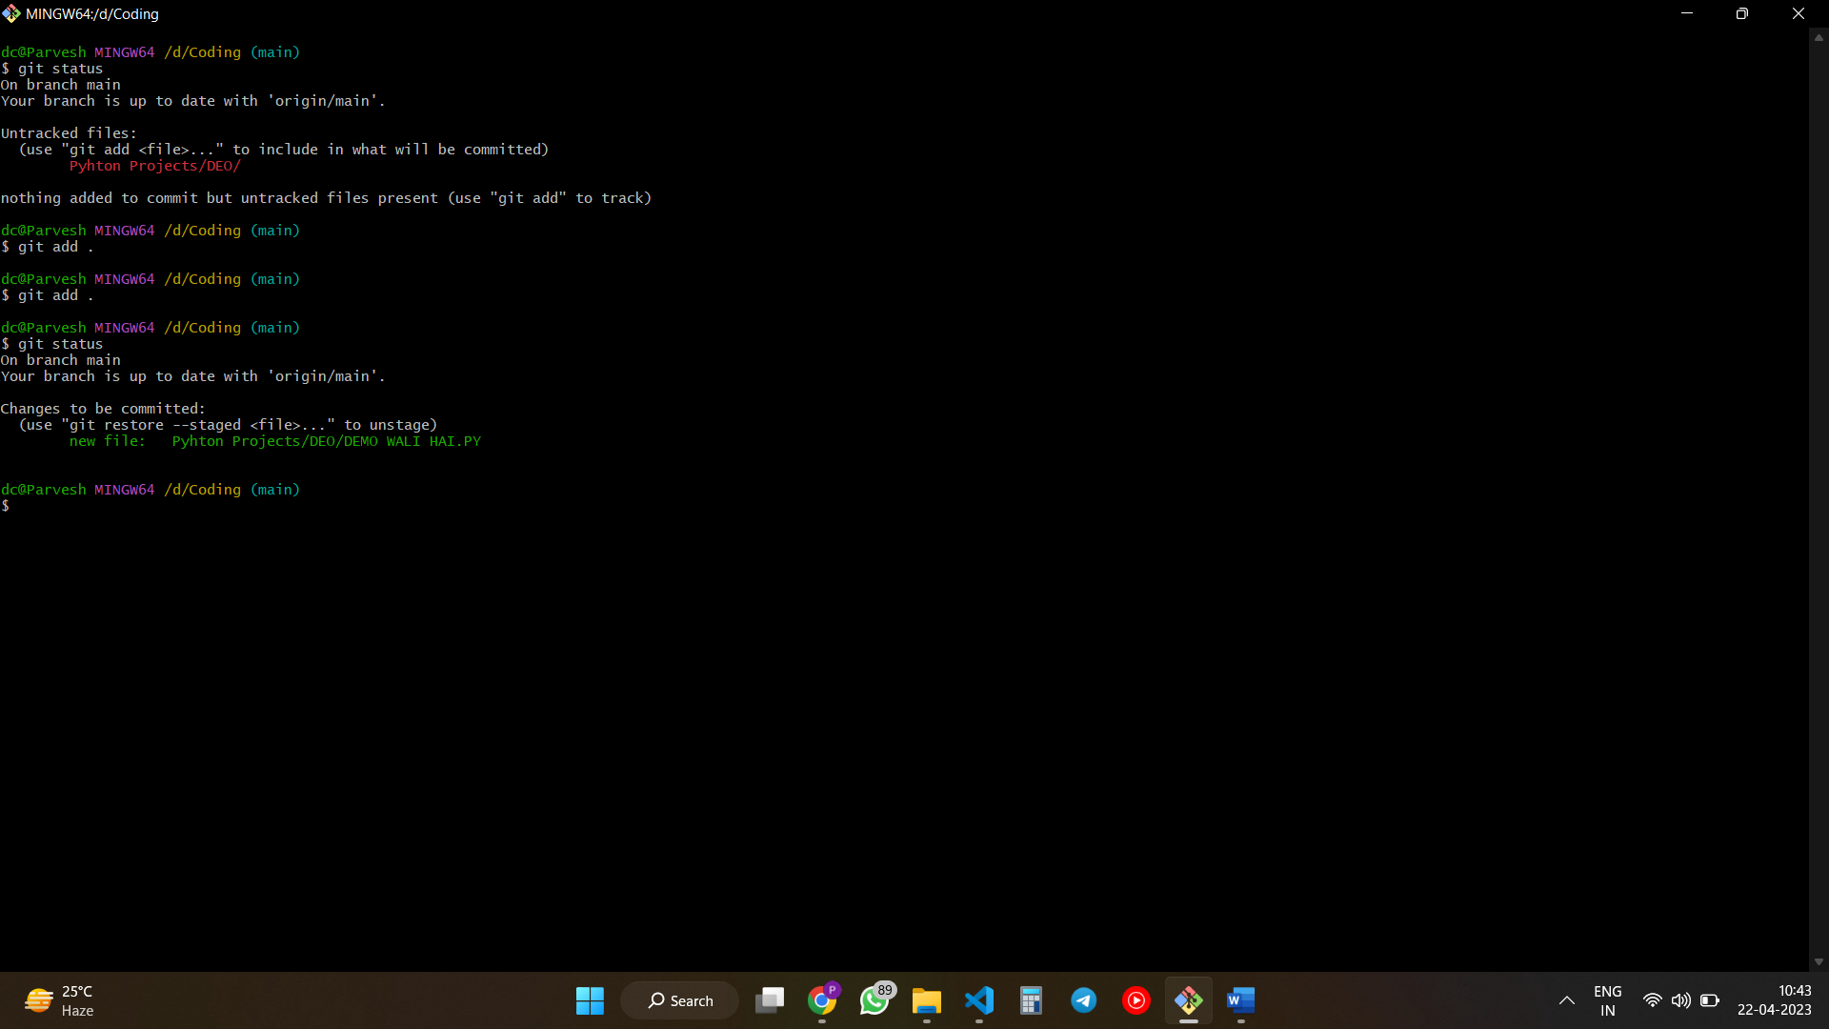

Git commit -m “ kuch b likh de”

// m stand for message

Now again check the status

Eb dhek upper jio ek file gree hore thi vo ne hai to es ke mtlb commit hori hai

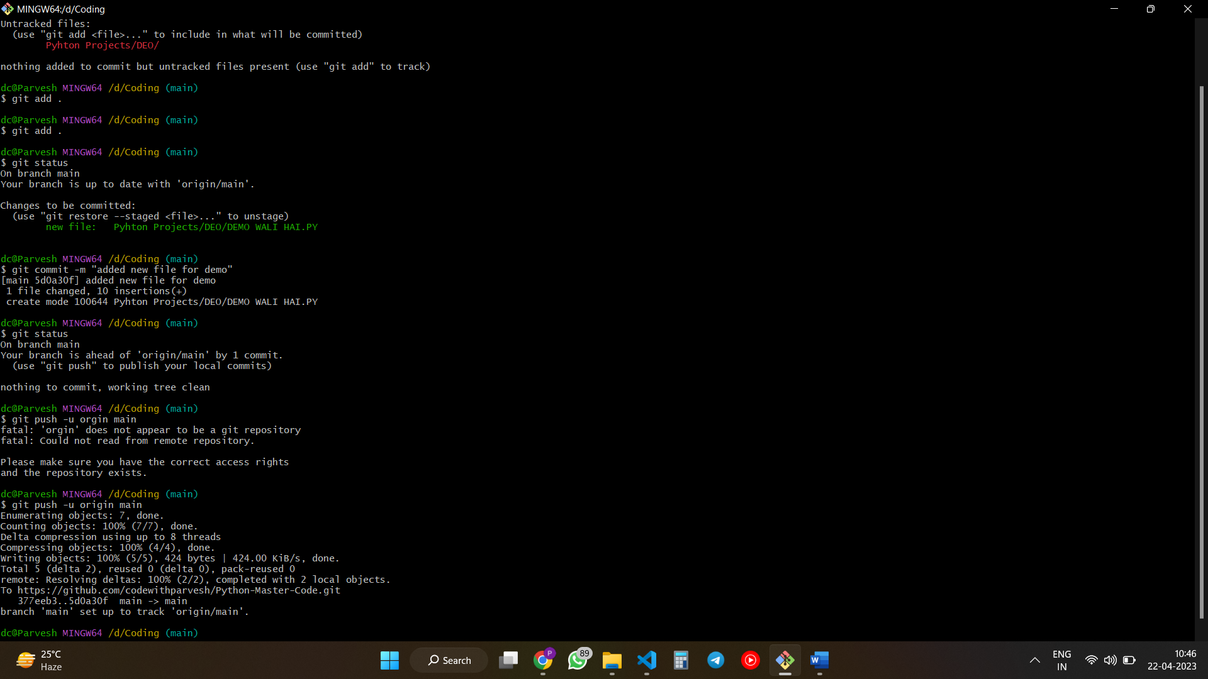

Now push by use git push -u origin main